Title:
An in-silico assessment of the accuracy of transcutaneous CO₂ monitoring – Good enough to be the pulse ox of ventilation?

Background:
Hypercapnic respiratory failure is a widespread and consequential problem with prognostic significance.^{1–6} However, the diagnostic gold standard of arterial blood gas (ABG) sampling requires expertise and has significant drawbacks to regular performance such as pain and complications including arterial injury, thrombosis, and blood stream infections.^{7,8} Transcutaneous CO₂ monitoring (TcCO₂) offers a potential alternative unmarred by such issues, though its adoption has been limited by concerns that its ability to detect hypercapnia may be insufficient to warrant widespread clinic implementation.^{9,10} In the present simulation we aim to evaluate the accuracy of TcCO₂ to identify hypercapnia based on existing data.

Methods:
The TriNetX network database (which provided access to electronic medical records (diagnoses, procedures, medications, laboratory values, genomic information) from approximately 115 million patients from 75 healthcare organizations) was accessed on 06/02/2023 for all encounters in which an arterial CO2 (PaCO₂) was obtained. For each PaCO₂ value, we simulated a corresponding TcCO₂ reading using results from a meta-analysis by Conway et al.¹⁰ wherein mean bias of TcCO₂ compared to PaCO₂ and uncertainty (within- and inter-population disagreement) were reported. Setting-specific values of bias and uncertainty as reported by Conway et al. were used for the corresponding locations of PaCO₂ testing and included the ambulatory pulmonary function test unit (PFT), emergency department and inpatient wards (ED/Inp), and intensive care unit (ICU). Each simulated TcCO₂ was then classified as true or false negative or positive by comparing the presence of arterial hypercarbia (PaCO₂ ≥45mmHg) to that of TcCO₂ under two different definitions. The first classification scheme used a strict TcCO₂ hypercarbia threshold of ≥45mmHg. The second classification system applied more extreme boundaries of classification of TcCO₂ (normal: <40mmH; hypercarbia ≥50mmHg) in order to separately evaluate test characteristics for only those TcCO₂ values that are further from borderline classification. TcCO₂-PaCO₂ agreement was then used to estimate sensitivity (Se), specificity (Sp), and negative and positive predictive values (NPV/PPV). Multi-level modeling and Monte-Carlo simulation were used to account for mean bias, within-study variance, between-study variance, and uncertainty in each parameter estimate.

Results:
168,663 ABGs were included across all clinical settings (91,503 ED/Inpt, 66,704 ICU, and 10,456 PFT). Median age was 61 years (IQR 51, 74), 54.7% were male, and race was comprised of 64.5% non-Hispanic White, 14.3% Black, 5.4% Hispanic, and 1.9% Asian. Mean PaCO₂ for all aggregated patients was 42.5 ± 16.1. The proportion with PaCO₂ ≥ 45 mmHg was 26.5% (PFT), 29.3% (ED/Inp), and 31.7% (ICU). Applying a definition of hypercarbia by TcCO₂ of ≥45mmHg yielded the following operating characteristic estimates: Se: 82.0%-93.1%; Sp: 94.4%-97.0%; NPV: 92.8%-96.7%; and PPV: 85.2%-91.9%. The greatest false negative and false positive rates were 5.1% in the ED/Inp group and 3.8% in the PFT group, respectively. With the more extreme TcCO₂ cutoffs, values for Se/Sp/NPV/PPV all increased to >99% with false classification rates of <1% across all settings.

Discussion:
Our current simulation suggests a high degree of accuracy of TcCO₂ in detection of hypercapnia across different clinical settings. Although some patients with borderline values of PaCO₂ may be misclassified based upon TcCO₂, this rate of misclassification dramatically decreases with the application of slightly more extreme cutoffs of TcCO₂ that exclude a midrange of values (40-50mmHg) that are likely to not be of significant clinical consequence anyways. In other words, these data support that, should a cut-off for hypercapnia by TcCO₂ of ≥50mmHg be used, the detection of true hypercapnia would be extremely accurate with a false positive rate far below 1% regardless of clinical setting.

Limitations to this work include that this is an estimation of the accuracy for identification of hypercapnia if applied broadly to situations where ABGs are currently obtained, potentially representing a patient population with more extreme derangements than those who have not undergone arterial sampling. We have also assumed a gaussian distribution of error in PaCO₂-TcCO₂ agreement which may not be accurate. Furthermore, two potentially important points of detail are not captured in our data. First, we have limited hypercapnia to a dichotomous outcome rather than reflecting the true, continuous nature that may inform nuanced clinical practice. Secondly, we did not evaluate test characteristics within specific physiologic states that may compromise accuracy (ie shock) nor for different TcCO₂ monitoring devices.

Conclusions
TcCO₂ may have a role in detection of clinically significant hypercapnia across multiple clinical settings with a low likelihood of making large mistakes in binary classification. Adoption in regular clinical practice may thus be useful when either the drawbacks/requisite skills of arterial sampling are prohibitive or continuous monitoring is desired for high risk populations, akin to the unambiguous utility of the pulse oximeter in obviating the need for routine arterial sampling in assessment of oxygenation status. Furthermore, such granularity that continuous monitoring could provide would be a welcome inclusion in the expanding field of research in ventilatory physiology.

Funding
This work is supported by grants from the American Thoracic Society (ASPIRE fellowship), the Intermountain Foundation, and the National Institutes of Health (Ruth L. Kirschstein National Research Service Award 5T32HL105321 and National Center for Advancing Translational Sciences Award UM1TR004409).

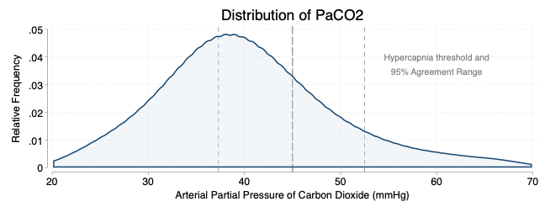

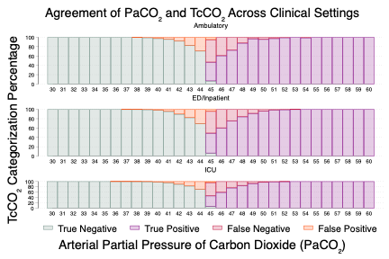

1. Konishi M, Akiyama E, Suzuki H, et al. Hypercapnia in patients with acute heart failure. ESC Heart Fail. 2015;2(1):12-19. doi:10.1002/ehf2.12023
2. Nin N, Muriel A, Peñuelas O, et al. Severe hypercapnia and outcome of mechanically ventilated patients with moderate or severe acute respiratory distress syndrome. Intensive Care Med. 2017;43(2):200-208. doi:10.1007/s00134-016-4611-1
3. Wilson MW, Labaki WW, Choi PJ. Mortality and Healthcare Use of Patients with Compensated Hypercapnia. Ann Am Thorac Soc. 18(12):2027-2032. doi:10.1513/AnnalsATS.202009-1197OC
4. Fazekas AS, Aboulghaith M, Kriz RC, et al. Long-term outcomes after acute hypercapnic COPD exacerbation : First-ever episode of non-invasive ventilation. Wien Klin Wochenschr. 2018;130(19-20):561-568. doi:10.1007/s00508-018-1364-6
5. Tiruvoipati R, Pilcher D, Buscher H, Botha J, Bailey M. Effects of Hypercapnia and Hypercapnic Acidosis on Hospital Mortality in Mechanically Ventilated Patients. Crit Care Med. 2017;45(7):e649-e656. doi:10.1097/CCM.0000000000002332
6. Locke BW, Richards WW, Gouripeddi R, et al. The Consistency of Hypercapnic Respiratory Failure Case Definitions in Electronic Health Record Data. Chest. Published online August 28, 2025:S0012-3692(25)05126-8. doi:10.1016/j.chest.2025.08.002
7. Baptistella CDPA, Mendes C de A, Silva MJ, Wolosker N. Retrospective Observational Single-Center Study of Complications of Arterial Indwelling Catheters for Invasive Blood Pressure in Intensive Care Unit Patients. Angiology. 2022;73(5):431-437. doi:10.1177/00033197211052127
8. Scheer B, Perel A, Pfeiffer UJ. Clinical review: complications and risk factors of peripheral arterial catheters used for haemodynamic monitoring in anaesthesia and intensive care medicine. Crit Care Lond Engl. 2002;6(3):199-204. doi:10.1186/cc1489
9. Farenden S, Chung Y, Cui A, Ferguson I. Prospective, observational study investigating the level of agreement between transcutaneous and invasive carbon dioxide measurements in critically ill emergency department patients. Emerg Med J EMJ. 2023;40(9):646-650. doi:10.1136/emermed-2022-212465
10. Conway A, Tipton E, Liu WH, et al. Accuracy and precision of transcutaneous carbon dioxide monitoring: a systematic review and meta-analysis. Thorax. 2019;74(2):157-163. doi:10.1136/thoraxjnl-2017-211466

